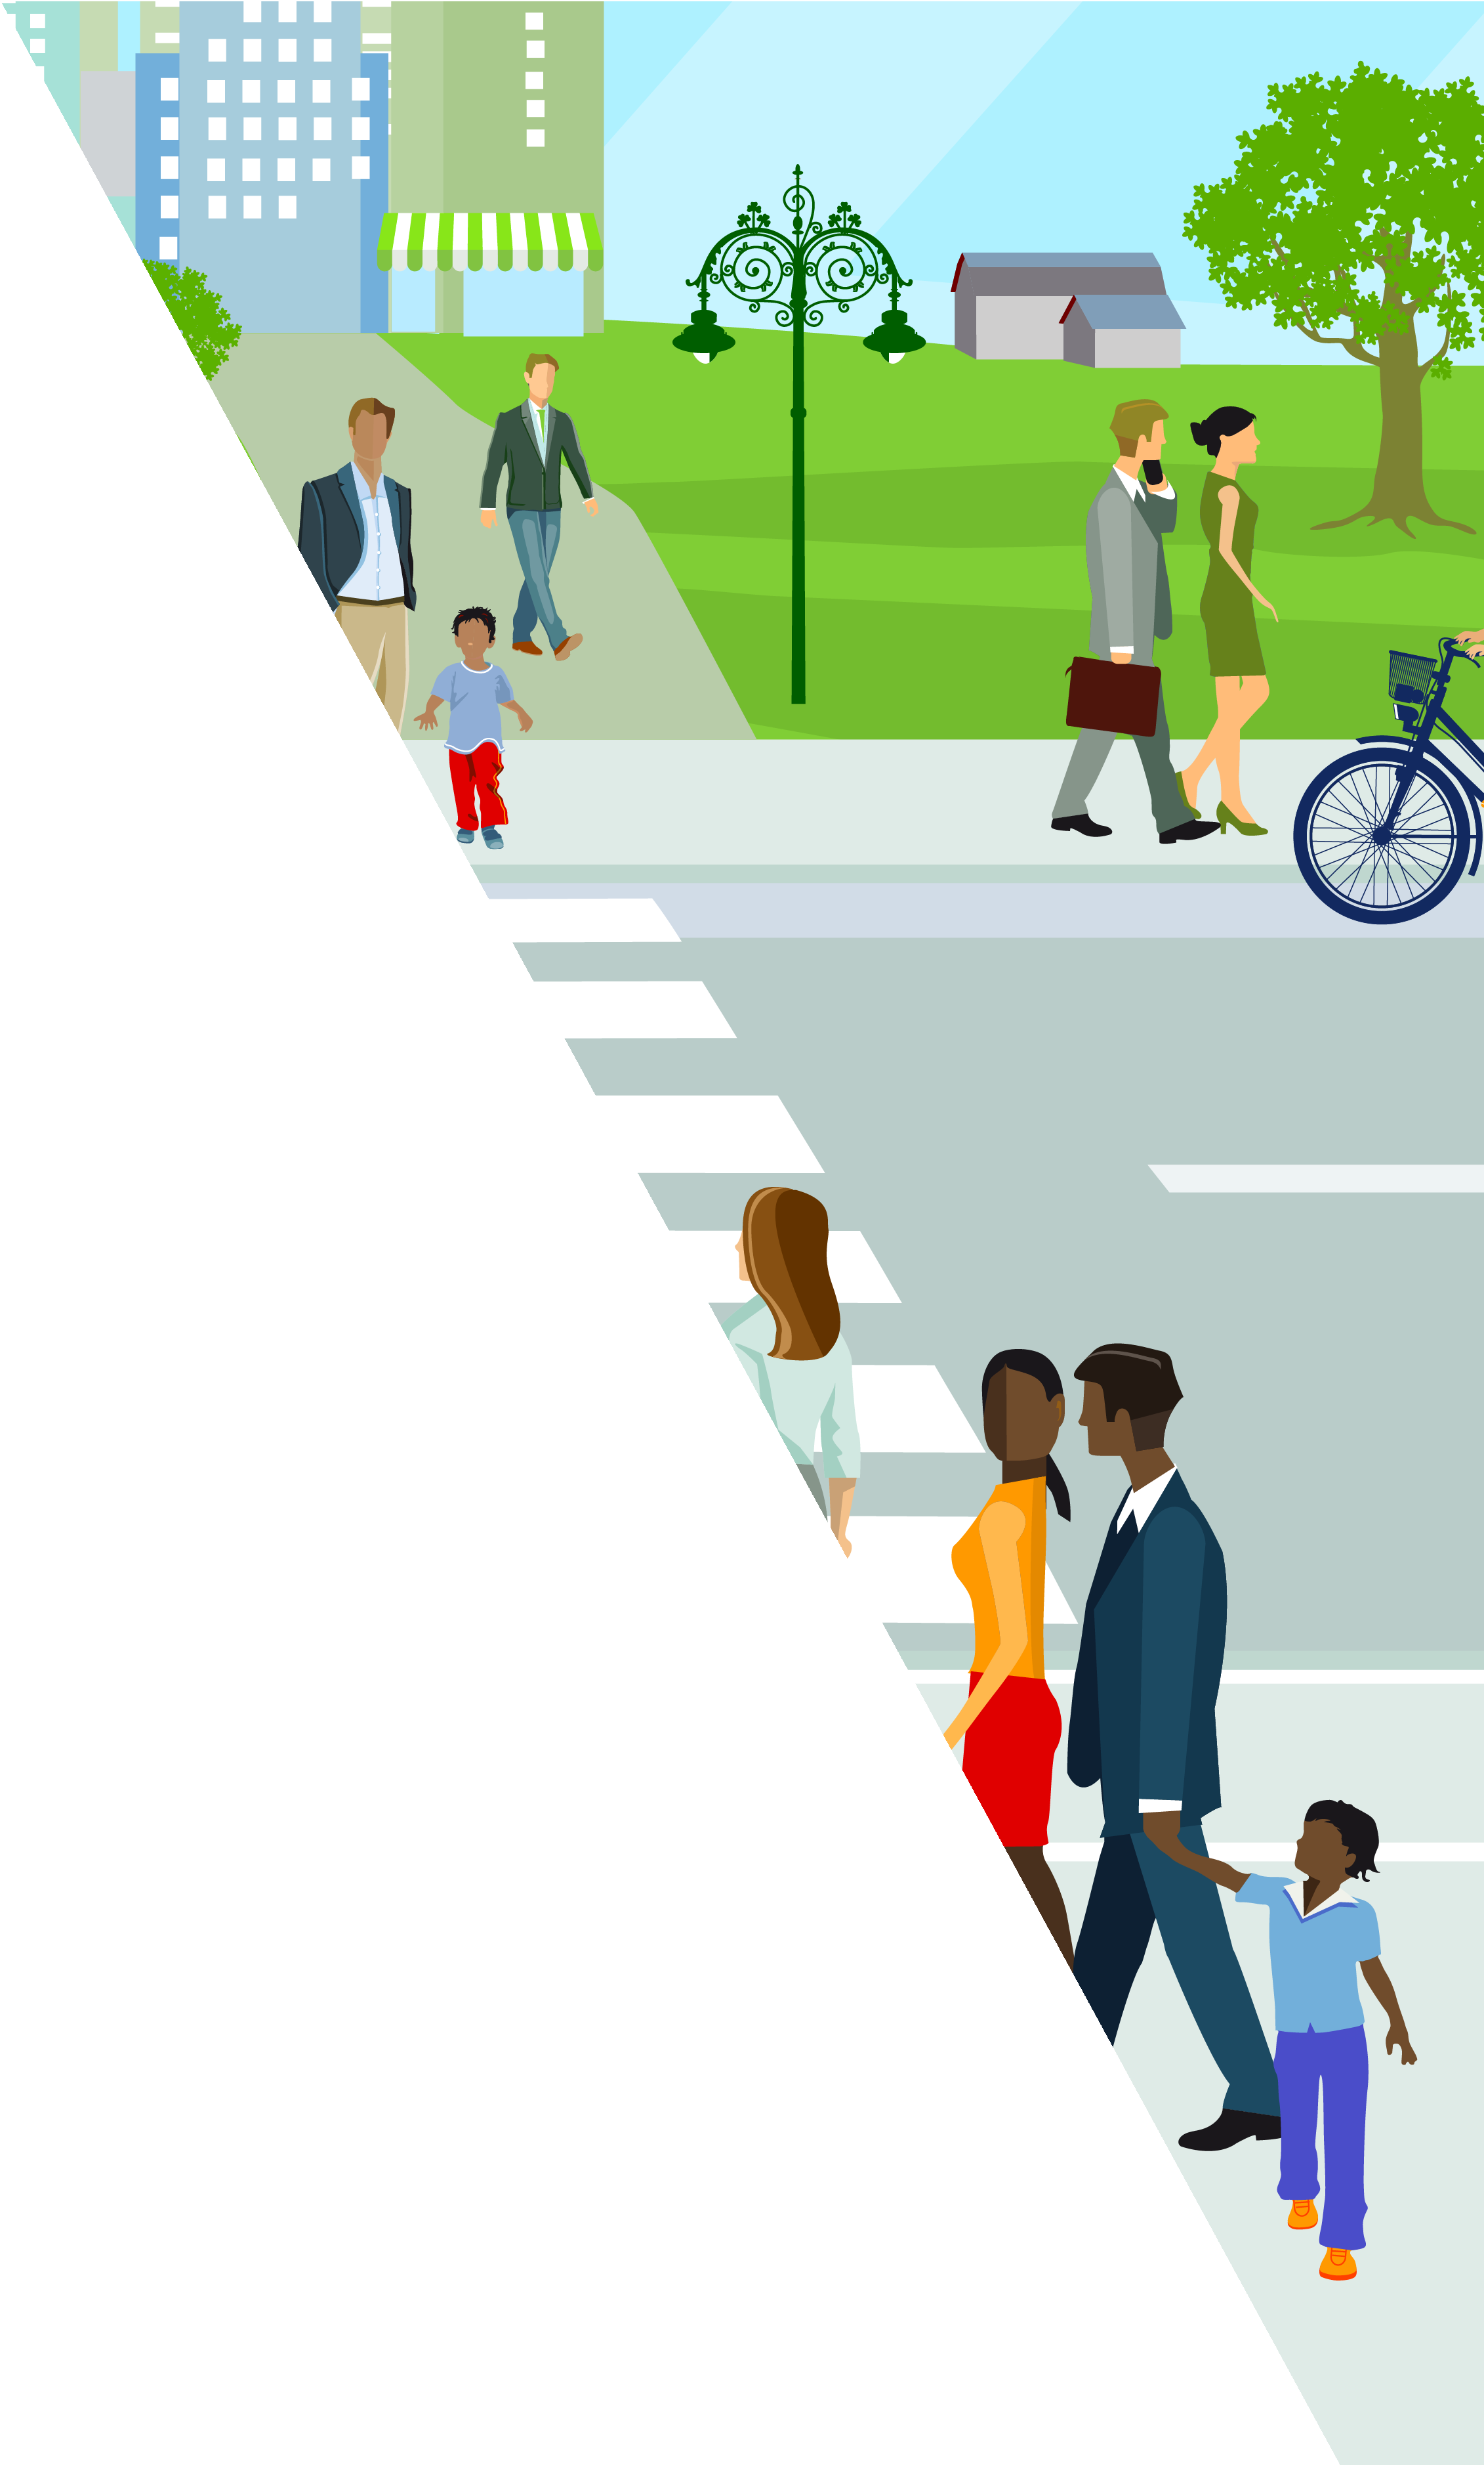

[INSERT MUNICIPALITY LOGO HERE]

[INSERT
MUNICIPALITY]
COMPLETE STREETS POLICY

April 2024

[INSERT MUNICIPALITY COMPLETE STREETS WEBSITE]

MUNICIPALITY LOGO]

COMPLETE STREETS POLICY

“Complete Streets” means a transportation philosophy that calls for streets to be constructed and operated in a way that considers the needs of all users and enables equitable and safe access. Complete Streets are planned, designed, constructed, operated, and maintained to accommodate people of all ages and abilities safely and comfortably, including pedestrians, cyclists, transit users, motorists, as well as freight and service operators.

In 2014, The Florida Department of Transportation (FDOT) adopted a Complete Streets policy to commit to enhancing the safety and mobility of its residents and visitors with Complete Streets principles. Since then, over 80 local governments statewide have adopted a Complete Streets policy and constructed Complete Streets projects that accommodate multiple modes of transportation for people of all ages and abilities. [INSERT MUNICIPALITY] shall construct and operate a comprehensive Complete Streets transportation system that enables safe access, mobility, economic development, attractive public spaces, health, and well-being for all people. This Complete Streets policy recognizes that depending on context, streets may serve diverse activities, functions, and intensity of uses. This policy was developed using Smart Growth America’s Complete Streets Policy Framework, representing the current best practices for creating a strong policy that can be implemented at any level of governance.

MUNICIPALITY LOGO]

VISION & INTENT

Complete Streets contribute directly to the health, safety, economic vitality, environment, and quality of life in [INSERT MUNICIPALITY]. Through implementation of this Complete Streets Policy, [INSERT MUNICIPALITY] shall consistently plan, design, construct, and maintain transportation facilities that are safe, reliable, efficient, convenient and connected and that enable secure and comfortable access and mobility for users of all ages, abilities and transportation modes. This policy recognizes that all modes cannot receive the same type of accommodation on every street; the overarching goal is that everyone has the ability to access the transportation system and travel throughout the network in a safe and comfortable manner. To accomplish this goal, the [INSERT MUNICIPALITY] is committed to prioritizing transportation investments which make walking, biking, public transit, and shared mobility safe, attractive, and viable travel options in [INSERT MUNICIPALITY].

This policy confirms [INSERT MUNICIPALITY] commitment to integrating and prioritizing all transportation system users when making decisions regarding transportation and land use planning to advance Complete Streets to the greatest extent possible, prioritizing safe access for vulnerable users and under-invested and underserved communities and ensuring social equity through improved access to jobs, health care and other community amenities.

A Complete Streets Network may be achieved through projects both incrementally or through a series of smaller improvements over time.

MUNICIPALITY LOGO]

GOALS

This policy shall directly support the goals stated below.

Safety and Convenience for All Transportation Users
Create a safe transportation system that prioritizes the elimination of crashes that result in death and serious injuries, recognizes that humans make mistakes and the responsibility is shared, and that proactive tools must be used to identify and address safety issues to provide a safe, accessible, and connected transportation for people of all ages and abilities.

Equity
Create a transportation system that, to the greatest extent possible, ensures equity by actively pursuing the elimination of health, economic and access disparities.

- Connected Facilities that Accommodate All Travel Modes Create a transportation system that includes integrated networks of connected facilities accommodating all modes of travel.

Increase Walking, Bicycling, and Public Transit
Create a transportation system that encourages walking, bicycling and public transit.

Economic Development
Create a transportation system that promotes economic development and supports redevelopment of and connectivity to activity centers.

Community Health & Sustainability
Create a transportation system that reduces automobile dependency and improves environmental and community health (i.e. reduce fossil fuel consumption & greenhouse gas emissions; decrease air and noise pollution; improve air quality; encourage social interaction and physical activity; preserve the natural environment; etc.).

MUNICIPALITY LOGO]

DIVERSE USERS

Roadway projects shall accommodate all transportation system users including but not limited to motorists/truck operators, pedestrians, bicyclists, transit riders, seniors, children, those with pets, people with disabilities and emergency responders, while respecting the access and context needs of adjacent land uses. The [INSERT MUNICIPALITY] shall provide safe, convenient, reliable, affordable, accessible, and timely transportation choices, regardless of race, ethnicity, religion, income, gender identity, sexual orientation, immigration status, age, ability, languages spoken, or level of access to a personal vehicle.

In creating Complete Streets, [INSERT MUNICIPALITY] recognizes equity as a motivation and will prioritize vulnerable users in the Traditionally Underserved Index (TUI) areas identified by the Palm Beach Transportation Planning Agency (TPA). Compared to the broader region, the TUI areas have higher proportions of the following populations groups:
- Non-white population
- Hispanic or Latino population
- Persons below poverty
- Limited English proficiency
- Persons with disabilities
- Persons over 65 years of age
- Persons between ages 5 to 21
- Zero vehicle households
- Persons with less than a High School Diploma

Vulnerable users shall be prioritized. Vulnerable users in transportation are defined as, but not limited to; racial minorities, persons with physical and psychiatric disabilities, young and aging individuals, immigrants, pedestrians, bicyclists, persons who do not have access to a personal vehicle, persons with less than a High School Diploma, persons with limited English proficiency, gender and sexual minorities, persons of low-income, etc. Special attention in the design and planning of a project shall be given to addressing the needs of people with disabilities and the elderly so that proposed complete improvements make a measurable difference in ease of travel, comfort, and safety for these most vulnerable users. Infrastructure investments shall be mapped, quantified, and evaluated to ensure the provision of Complete Streets projects in all neighborhoods, avoiding pockets of disinvestment or underinvestment. Vulnerable users that are in neighborhoods with insufficient infrastructure and neighborhoods with a concentration of people who are disproportionately represented in traffic fatalities and serious injuries shall be prioritized.

MUNICIPALITY LOGO]

[INSERT MUNICIPALITY] shall strive to overcome barriers with engagement in the development of transportation projects with populations affected by a project including, but not limited to, associated with race, income, age, disability, English language proficiency, and vehicle access. This includes identifying a means of measuring success in overcoming these barriers and ensuring all populations are included in the engagement process.

In implementing this policy, [INSERT MUNICIPALITY] shall strive to mitigate unintended consequences associated with Complete Streets projects, such as involuntary displacement, through community engagement and focusing on context-sensitive solutions.

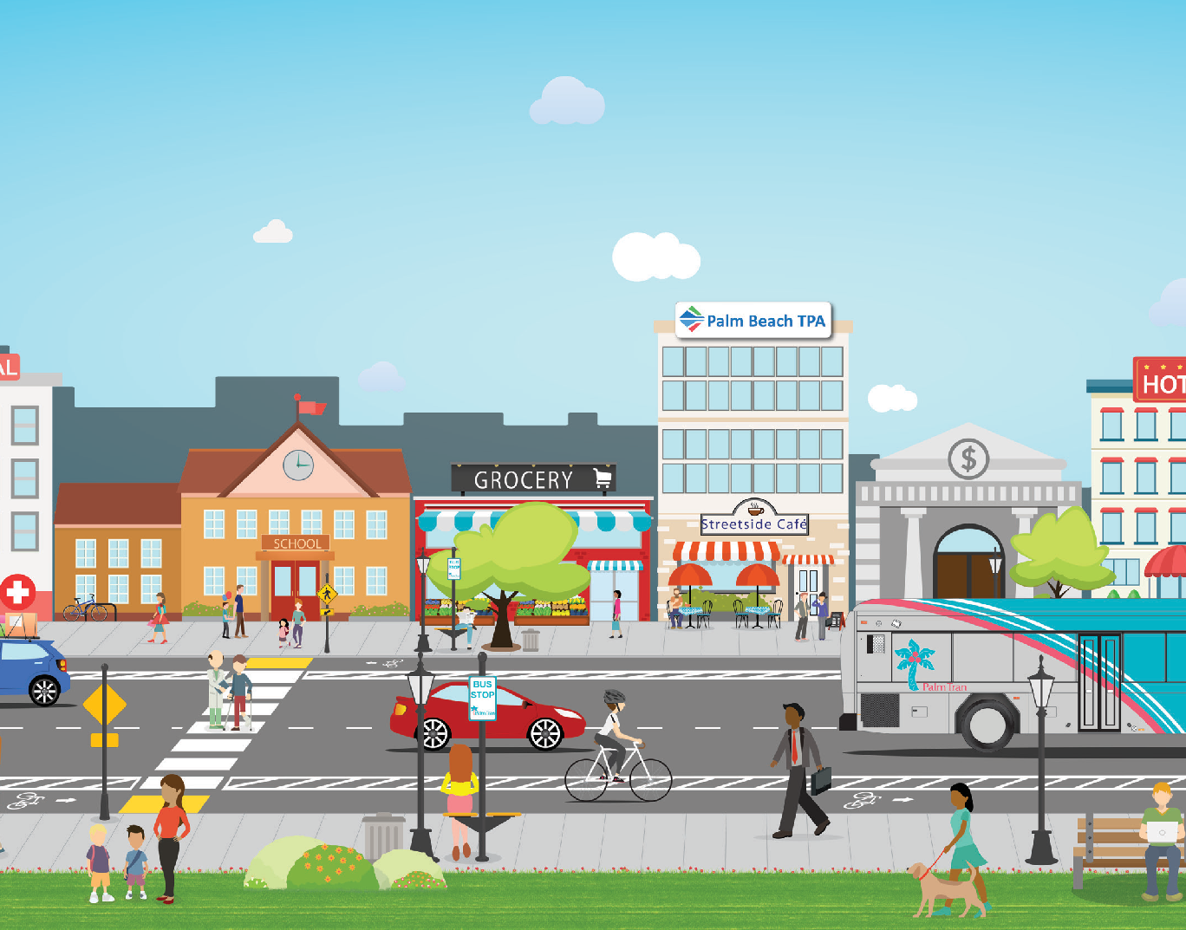

MUNICIPALITY LOGO]

APPLICABILITY

Except as otherwise stated below, this policy applies to all project phases undertaken by or under the authority of or subject to the supervision of [INSERT MUNICIPALITY], for the improvement of any street and public right of way (ROW), including planning, programming, design, acquisition of land, construction, construction engineering, reconstruction, rehabilitation, resurfacing, repaving, re-striping, retrofit and operation to account for the needs of all modes of transportation and all users of the road network. All modes of transportation to safely use the roadway shall be evaluated for improvement and provided during construction or repair work when identified demands are not met.

In the case a project is within or connects to [INSERT MUNICIPALITY] and is owned by another entity, [SPECIFY DEPARTMENT] staff shall work with the ROW owner, Florida Department of Transportation (FDOT), Palm Beach County, and Palm Beach TPA as appropriate, to the greatest extent possible, to advance Complete Streets improvements. In addition, this policy requires [INSERT MUNICIPALITY] [INSERT APPROPRIATE DEPARTMENT] staff to evaluate new development and redevelopment projects and require connected pedestrian and bicycle access as well as ADA compliant facilities within the development and connecting to and from the surrounding transportation system for approval.

[INSERT MUNICIPALITY] will approach every planned project as an opportunity to create safer and more accessible transportation system for all users.

The following conditions must be met to provide an exception to Complete Streets:
- LIMITED-ACCESS ROADS: This policy does not apply to limited access facilities where bicyclists and pedestrians are prohibited by law. People walking and bicycling shall be provided a parallel facility to provide safe, comfortable crossings at such locations. Interchanges and neighborhoods, and connections to activity centers, or the regional trail network shall have Complete Streets improvements to protect the integrity of the network.
- ORDINARY MAINTENANCE: This policy does not apply to routine maintenance, such as mowing, cleaning, sweeping, pothole filling, concrete joint repair, and other regular or seasonal maintenance.
- PRE-EXISTING PROJECTS: This policy does not apply to a project in final at or above 60% design or under construction as of [INSERT EFFECTIVE DATE]

All exceptions shall be specific and approved by [INSERT HIGH-LEVEL OFFICIAL TITLE / DEPARTMENT]. Any other exception not mentioned above shall require public notice such as a public meeting or an online posting with opportunity for public comment.

MUNICIPALITY LOGO]

COORDINATION & ENGAGEMENT

Coordination and commitment from all agencies involved are required for success. This policy shall require inter-agency coordination between various agencies such as public health, housing, planning, engineering, transportation, public works, city council, and/or mayor or executive office. [INSERT MUNICIPALITY] is committed to being a leader in this effort. Some of the agencies involved include, but are not limited to:

- The Florida Department of Transportation (FDOT)
- Palm Beach County (PBC)
- Palm Beach Transportation Planning Agency (TPA)
- Palm Beach County School District
- Developers
- Property owners
- Advocacy groups
- Members of the public, especially vulnerable road users

Community engagement is also essential to the success of Complete Streets, particularly in the planning and design phases. Regular engagement shall occur prior to the planning and design of specific capital projects. Additionally, resources shall be allocated to proactive efforts to interact with the community to identify and communicate their experience regarding existing transportation facilities and identify areas of need and opportunity.

LAND USE & CONTEXT SENSITIVITY

Complete Streets implementation should be sensitive to the community’s physical, economic, and social setting. A context-sensitive approach to process and design considers stakeholder and community values. The overall goal of this approach is to preserve and enhance scenic, aesthetic, historical, and environmental resources while improving or maintaining safety, mobility access, and infrastructure conditions.

[INSERT MUNICIPALITY] shall refer to the Palm Beach TPA’s Complete Streets Design Guidelines and the FDOT’s Design Manual’s and Complete Streets Context Classification when determining Complete Streets improvements for transportation projects.

MUNICIPALITY LOGO]

[INSERT MUNICIPALITY] shall also recognize the surrounding community’s current and future land use and transportation needs and collect community input to best fit the community’s desires while maintaining the connectivity of the transportation system as a whole for all modes and users. Input shall explicitly be sought from traditionally underserved communities in the project area. Unintended consequences to those populations, including potential gentrification and/or involuntary displacement shall be mitigated.

[INSERT MUNICIPALITY] shall require new and revised land use policies, plans, and zoning ordinances to specify how transportation projects will serve current and future land use needs and include language that requires the consideration of the community context as a factor in decision-making, as well as specifying the need to understand and mitigate unintended consequences of projects or plans, such as involuntary displacement.

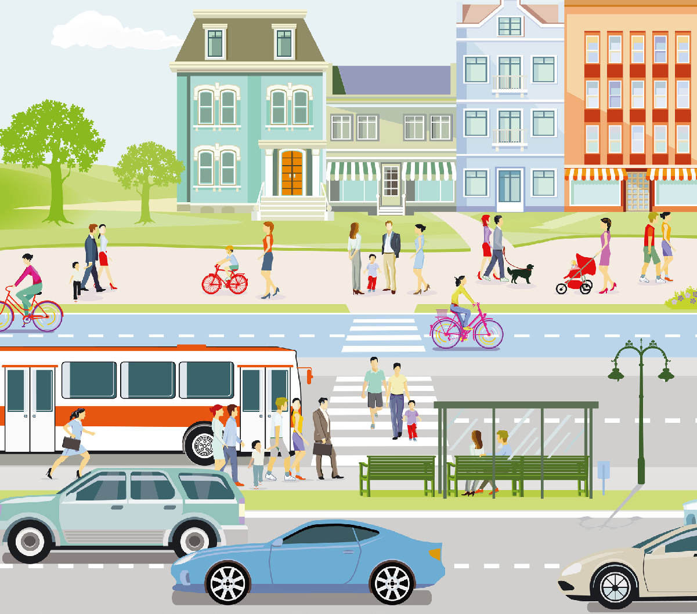

MUNICIPALITY LOGO]

COMPLETE STREETS DESIGN

Transportation projects and maintenance activities shall be:

- Suitable and appropriate to the function and context of the transportation facility;
- Sensitive to the neighborhood context and cognizant of the neighborhood needs;
- Flexible in project design to ensure that all users have safe access and use;
- Included as a component of a comprehensive, integrated and interconnected transportation network that allows all users to choose between different modes of travel; and
- Consistent and compatible with [INSERT MUNICIPALITY]’s Bicycle Facilities Plan/ Comprehensive Plan/Other

[INSERT MUNICIPALITY] shall require speed management strategies to reduce vehicle speeds, minimize conflicts between street users, and enhance the neighborhood environment. Strategies that apply to speed management include adding traffic calming elements to a road, setting speed limits that are safe and reasonable, and using signal timing strategies such as dwell-on- red, pedestrian recall, leading pedestrian intervals and any signal coordination to alter driver behavior and therefore improve conditions for pedestrians and bicyclists. Furthermore, for projects where budget, time, or planning is limited, [INSERT MUNICIPALITY] shall consider tactical urbanism strategies, or otherwise known as quick-builds, pop-ups, etc., that can provide low-cost, temporary changes to the built environment to pilot or implement Complete Streets infrastructure. An approach complementary to Complete Streets is the Safe System Approach. This approach aims to eliminate all traffic-related fatal and serious injuries for all road users through a holistic view of the road system that first anticipates human mistakes and second keeps impact energy on the human body at tolerable levels. [INSERT MUNICIPALITY] shall incorporate this approach when developing projects, and be creative in incorporating walking, bicycling, and transit facilities upon routine roadway maintenance projects.

Facilities shall be designed and constructed in accordance with current applicable laws and regulations, using best practices and guidance from a variety of organizations absent conflict with this Complete Streets policy.

- Palm Beach Transportation Planning Agency Complete Streets Design Guidelines
- The American Association of State Highway and Transportation Officials (AASHTO) Guide for Planning Design and Operation of Pedestrian Facilities

- ASHTO Guide for the Development Of Bicycle Facilities
MUNICIPALITY LOGO]

- USDOT Achieving Multimodal Networks: Applying Design Flexibility & Reducing Conflicts
- Federal Highway Administration (FHWA) Separated Bike Lane Planning and Design Guide
- FHWA Incorporating On-Road Bicycle Networks into Resurfacing Projects Report
- FHWA Separated Bike Lane Planning and Design Guide
- Institute of Transportation Engineers (ITE) Designing Walkable Urban Thoroughfares: A Context Sensitive Approach
- National Association of City Transportation Officials (NACTO) Global Street Design Guide, Urban Streets Design Guide, Urban Bikeway Design Guide, Transit Street Design Guide, Urban Street Stormwater Guide
- National Cooperative Highway Research Program (NCHRP), Report 616, Multi-Modal Level Of Service Analysis For Urban Streets
- NCHRP Guide for Pedestrian and Bicyclist Safety at Alternative and Other Intersections and Interchanges
- FHWA Speed Management: A Manual for Local Rural Road Owners
- FDOT Context Classification Guide
- FDOT Quality/Level of Service (Q/LOS) Handbook

Design standards required for State or federally funded projects will supersede local requirements if there is an actual conflict between the local and State or Federal standards and if funding will be impacted by adherence to the local standard.
Design Standards include, but are not limited to the following:

- Americans with Disabilities Act (ADA) Standards for Accessible Design
- AASHTO A Policy on Geometric Design of Highways and Streets (AASHTO Green Book)
- FDOT Design Manual
- FDOT Manual of Uniform Minimum Standards for Design, Construction and Maintenance (Florida Green Book)
- FDOT Plans Preparation Manual (PPM)
- United States Department of Transportation (USDOT) Manual on Uniform Traffic Control Devices (MUTCD)
- FHWA’s Public Right-of-Way Accessibility Guidelines (PROWAG)

MUNICIPALITY LOGO]

MEASURE PROGRESS

The implementation of Complete Streets shall be a process that requires regular evaluation to determine progress and effectiveness. [INSERT MUNICIPALITY DEPARTMENT] shall develop and publicly publish performance measures on its website. [INSERT MUNICIPALITY DEPARTMENT] shall provide a written report to [INSERT AGENCY/PUBLIC OFFICIAL/ BOARD] and publish publicly on an annual basis a status update on each performance measure and the progress and effectiveness of the Complete Streets policy, including any exceptions granted from the Complete Streets policy.

Within the Annual Report, the performance measures that shall be evaluated include, but are not limited, to the following:

- Number of crashes and severity of injuries
- Injuries and fatalities for all modes
- Presence of adequate lighting
- Travel time in key corridors (point A to point B) by mode
- Number of trips by walking/rolling, biking, transit, and driving
- Number of transit facilities, biking facilities, and walking/rolling facilities
- Sidewalk conditions ratings
- Number of low-stress facilities
- Number of curb ramps
- Building vacancy rates
- Access to jobs by mode
- Temporary and permanent jobs created by project
- Emergency vehicle response tomes
- Number of students who walk or bike to school
- Number of mode user: walk, bike, transit
- Bike route connections to off-road trails
- Number of bike share users
- Air quality
- Number of street trees
- Number of temporary and permanent art installations
- Internal policies and documents updated
- Number of staff trained

- Effectiveness of community engagement process
- Miles of bicycle lanes, routes, or trails built / dedicated by width and type
- Number of bicycle parking facilities installed
- Number of traffic calming facilities built / installed
- Linear feet of pedestrian accommodations built or repaired
- Number of crosswalks built or improved
- Number of ADA accommodations built / installed
- Number of transit accessibility improvements built
- Number of street trees planted
- Number of exceptions approved
- User data - bicycle, pedestrian, transit and traffic counts
- Bicycle and pedestrian crash data involving serious injuries and fatalities
- Total dollar amount spent on Complete Streets improvements
MUNICIPALITY LOGO]

- Number of Complete Streets improvements and initiatives implemented in census tracts with populations that are above and below the county median number of persons of color.
- Number of Complete Streets improvements and initiatives in census tracts with households that are above and below the county median number of persons speaking a language other than English at home.
- Number of Complete Streets improvements and initiatives implemented in census tracts with households above and below 50% No Vehicle Access.
- Number of Complete Streets improvements and initiatives implemented in census tracts with the county median income above and below the median household income.
- Number of Complete Streets improvements and initiatives implemented in census tracts with higher than average county rates of chronic diseases (asthma, heart disease, obesity, etc.).
- Data related to both the internal and external performance measures outlined within this policy shall be collected, analyzed, and released to the public.

PROJECT SELECTION CRITERIA

[INSERT MUNICIPALITY] shall develop project scoring criteria to rank and prioritize funding of Complete Streets projects for implementation. The criteria shall incorporate various ranking components, such as an analysis of walking/bicycling/transit demand and gaps, network connectivity, existing crashes/fatalities, multimodal level of service improvements, and inclusion of Complete Streets elements.

MUNICIPALITY LOGO]

Additionally, criteria for project ranking must assign weight for active transportation infrastructure, projects that serve underserved communities, and alleviate disparities in geography, health, safety, and access. Criteria must also prioritize projects in neighborhoods where residents disproportionately rely on low-cost mobility options and shall, at a minimum, include criteria to direct investment to neighborhoods with higher concentrations of low-income individuals, people of color, and households without access to a private automobile. The ranking system shall also include additional equity-focused criteria to prioritize projects that directly benefit other vulnerable users of the transportation system such as children, aging adults, and people with disabilities.

During [INSERT MUNICIPALITY] annual budgeting process, projects that advance Complete Streets and the performance measures outlined in Section 7 shall be prioritized for funding. Complete streets projects must be either independently developed by the entity or seek out project funding from the Palm Beach TPA and other local partners.

IMPLEMENTATION STEPS

The implementation of Complete Streets will require cooperation and collaboration between many stakeholders on a regular basis. [INSERT MUNICIPALITY] shall take the following steps upon immediate adoption of this policy to facilitate the process:

- [INSERT MUNICIPALITY] shall restructure or revise related procedures, plans, regulations and other processes to accommodate all users on every project within the next [INSERT TIMEFRAME]. This could include incorporating Complete Streets checklists or other tools into decision-making processes.
- The [ENGINEERING/PUBLIC WORKS DEPARTMENT] shall establish necessary procedures to ensure Complete Streets principles are incorporated at the earliest stage of design within the next [INSERT TIMEFRAME].
- The [PLANNING DEPARTMENT] shall review and propose revisions to all appropriate land use ordinances, policies and regulations to support the implementation of Complete Streets on an on-going basis and within the next [INSERT TIMEFRAME].
- The [PLANNING DEPARTMENT] shall coordinate with the adopted bicycle and pedestrian plan or the development of a new bicycle and pedestrian plan within the next [INSERT TIMEFRAME].
- The [PLANNING DEPARTMENT AND PUBLIC WORKS/ENGINEERING DEPARTMENTS] shall
review, revise or recommend changes to all policies, procedures and design standards associated with site plan and other requirements for public and private development to ensure best practices are utilized to support Complete Streets on an on-going basis and within the next [INSERT TIMEFRAME].

[INSERT MUNICIPALITY LOGO]
- [INSERT MUNICIPALITY] shall develop new design policies and guides or revise existing to reflect the current state of best practices in transportation design within the next [INSERT TIMEFRAME]. [INSERT MUNICIPALITY] may also consider adopting national, state, or the Palm Beach TPA’s local design guidance.
- [INSERT MUNICIPALITY] commits to providing low-stress facilities to the maximum extent feasible on all roadway projects. [INSERT MUNICIPALITY] shall establish a Pedestrian and Bicycle Level of Traffic Stress (LTS) network analysis within the next [INSERT TIMEFRAME] to illustrate the areas with the highest to lowest comfort levels based on, but not limited to, posted speed limit, number of lanes, facility type, separation, etc.
- [INSERT MUNICIPALITY] shall continue to identify local, state and federal funds to implement Complete Streets Improvements to supplement [INSERT MUNICIPALITY]’s Capital Improvement Program. This will require a continued partnership and coordination with the Palm Beach TPA, FDOT and Palm Beach County.
- [INSERT MUNICIPALITY] shall promote collaboration and coordination between [INSERT MUNICIPALITY]’s departments and other transportation and planning agencies, including the Florida Department of Transportation and Palm Beach County.
- [INSERT MUNICIPALITY] will offer Complete Streets workshops and other training opportunities to transportation staff, community leaders, and the general public on a yearly basis so that everyone understands the importance of the Complete Streets vision. Complete Streets training could focus on Complete Streets design and implementation, community engagement, and or equity. [INSERT MUNICIPALITY] shall encourage staff professional development in the area of Complete Streets through attendance at seminars, conferences, and workshops.
- [INSERT MUNICIPALITY] shall create a committee to oversee implementation within the next [INSERT TIMEFRAME]. The committee shall include both external and internal stakeholders as well as representatives from advocacy groups, underinvested communities, vulnerable populations such as people of color, older adults, children, local- income communities, non-native English speakers, those who do not own or cannot access a car, and those living with disabilities.
- [INSERT MUNICIPALITY] shall create a community engagement plan within the next [INSERT TIMEFRAME] that includes equity by targeting advocacy organizations and underrepresented communities which could include non-native English speakers, people with disabilities, etc. depending on local context. This requires use of outreach strategies such as holding public meetings at easily accessible times and places, collecting input at community gathering spaces and hosting and attending community meetings and events. Outreach strategies shall make use of natural gathering spaces such as clinics, schools, parks, community centers, and other accessible public spaces.

Page 14

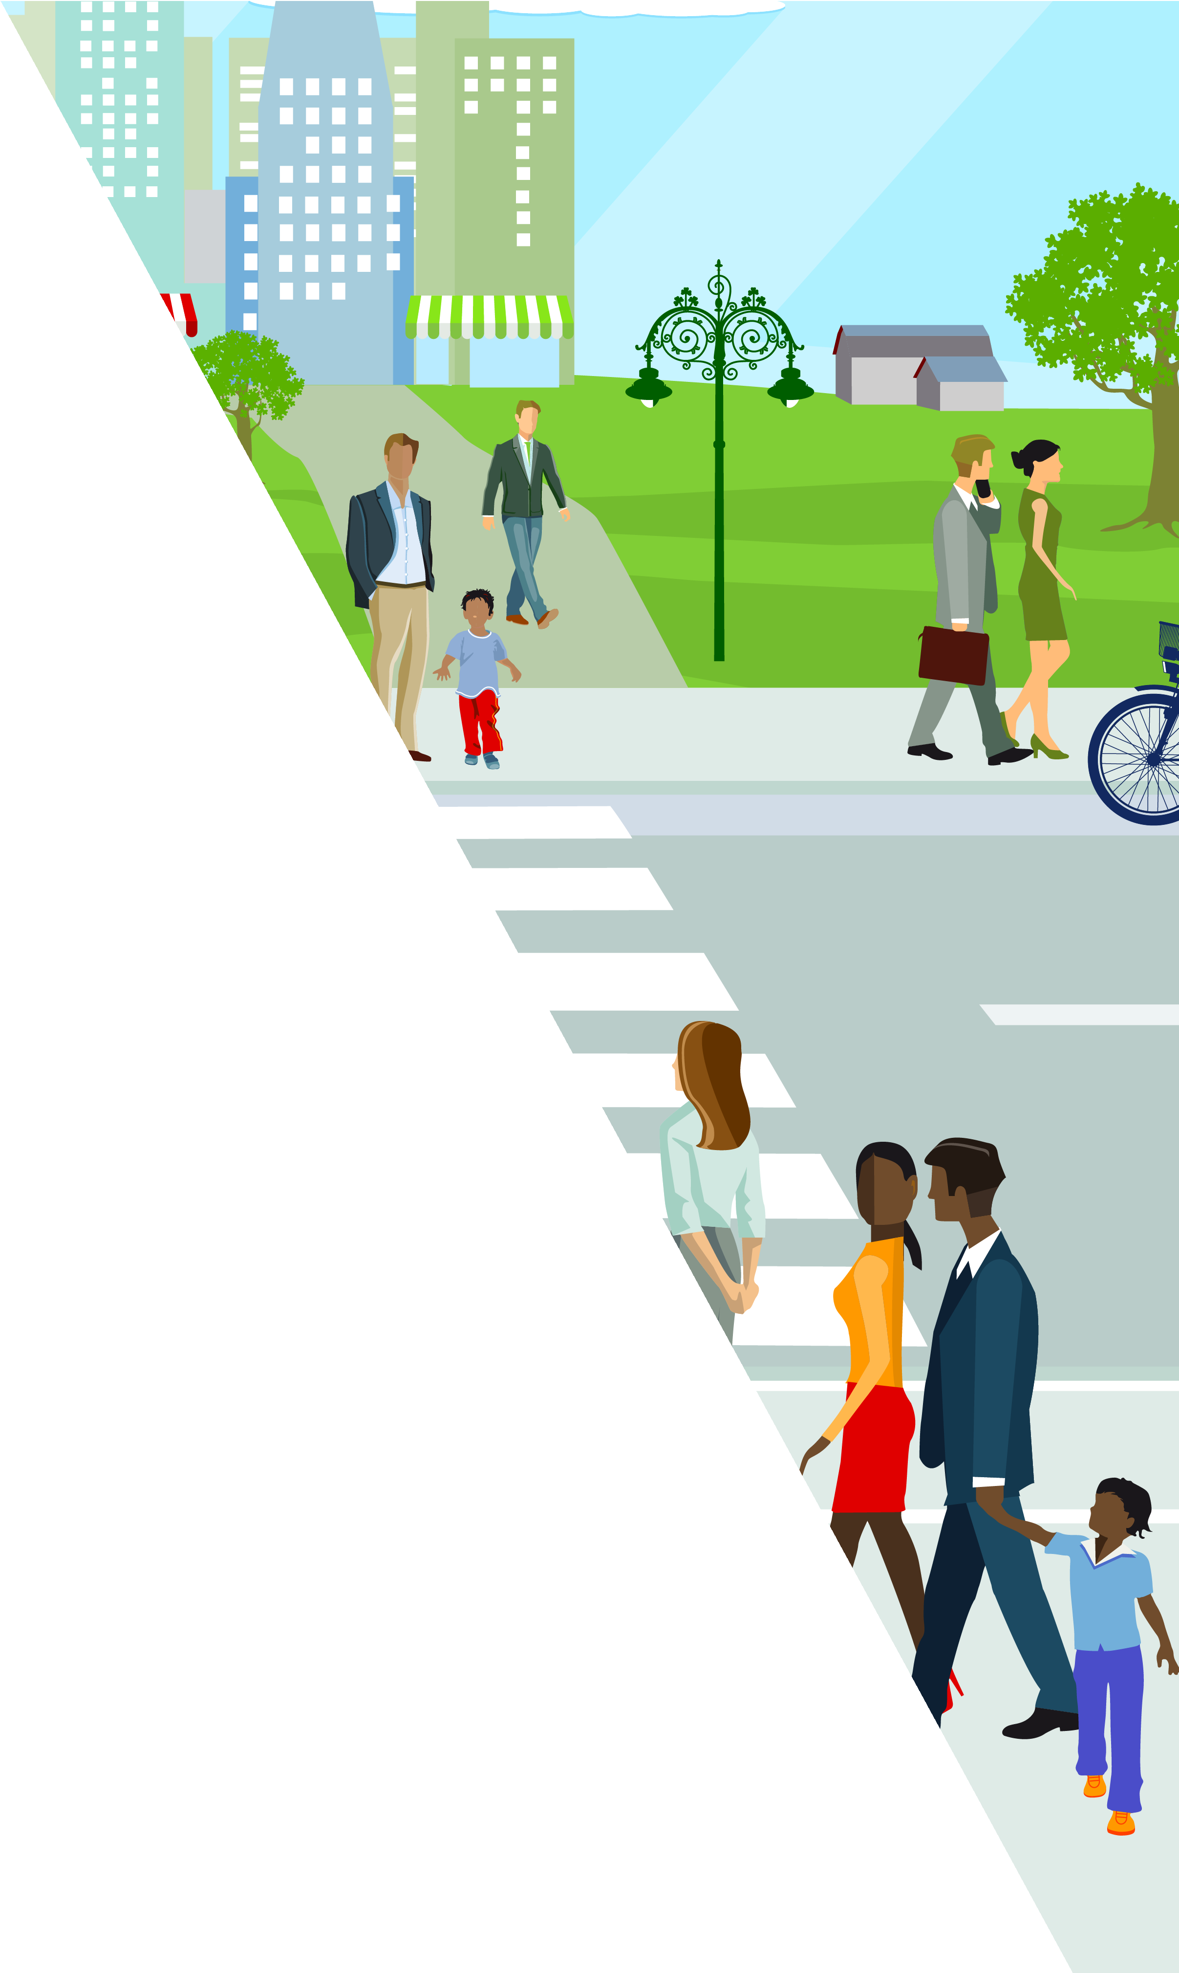

[INSERT
MUNICIPALITY LOGO HERE]

[INSERT MUNICIPALITY COMPLETE STREETS WEBSITE]

